***IOE Project Resources***

AWS IOT using esp8266 send data on cloud:

<https://www.youtube.com/watch?v=x9GfxgkEpXg>

Setting up IOT core for ESP

<https://youtu.be/xh8dYoj0xcA?si=jzgTxJUFCt_sm8kJ>

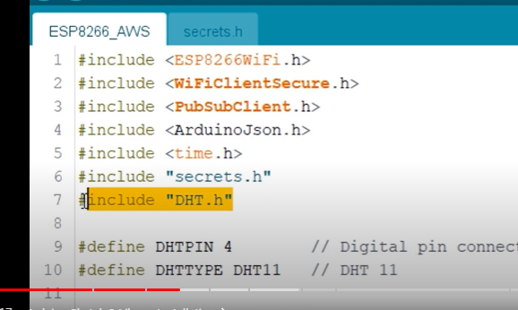

AWS IoT analytics

<https://www.youtube.com/watch?v=qp089yauQyI>

[Data dog](https://www.datadoghq.com/dg/monitor/aws-dashboards-benefits/?utm_source=google&utm_medium=paid-search&utm_campaign=dg-infra-apac-aws-india&utm_keyword=aws%20analytics&utm_matchtype=p&igaag=153090802232&igaat=&igacm=20461585326&igacr=670251760933&igakw=aws%20analytics&igamt=p&igant=g&utm_campaignid=20461585326&utm_adgroupid=153090802232&gad_source=1&gclid=CjwKCAjw8rW2BhAgEiwAoRO5rKFz6ERWjSoYnzenyJITeBuYLhcQE5UczqbmhGLfZeLoSnPxzNVRfxoCXmAQAvD_BwE)